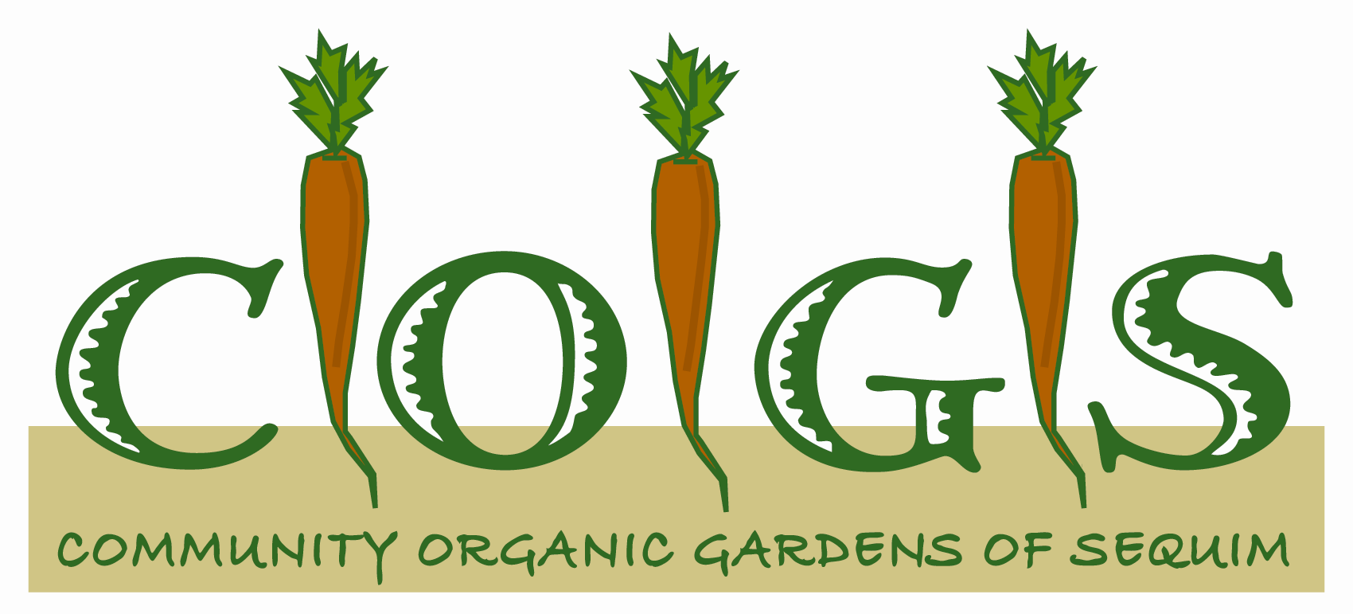

COGS offers garden plots for growing organically as well as a full day class/orientation to be held Saturday, March 9, 2019. Only organic methods are used in the garden. No chemical fertilizers, pesticides, or herbicides are allowed.

GARDENS: COGS has two locations, one on West Fir St. behind St. Luke’s Episcopal Church. The other, the City of Sequim’s June Robinson Memorial Park Garden, is on the corner of North Sunnyside and East Spruce.

PLOTS: In-ground plots vary in size and shape and average 100 square feet. There is a limited number of elevated beds that are approximately 2’ high and 32-40 sq. ft.

PLOTHOLDER FEES: The fee for a plot or a raised bed in either garden is $45. No refunds will be given after March 16, 2019.

GARDEN PLOT APPLICATION
Please print VERY clearly

Name________________________ Phone__________________
Address______________________________________________
Print email address below. All garden information is sent via email. _____________________________________________
____ Check or money order for $45 for in-ground plot is included.
____ Check or money order for $45 for an elevated bed is included.
_______________________________________________________

____ I prefer a plot/elevated bed in the Fir St Garden.
Make check/money order payable to COGS and mail with application to: Jaimi Primrose, 1700 Carlsborg Rd., Sequim, WA 98382. Questions? Call Jaimi at 360-808-3877.

____ I prefer a plot/elevated bed in the June Robinson Memorial
Park Garden.
Make check/money order payable to the City of Sequim
and mail with application to: Ann Holgerson, 152 W. Cedar St., Sequim, WA 98382.
Questions? Call Ann at 360-683-4139.

